Test case execution of Swaglabs site

SWAG-7: Checking URL

Step 1: Navigate to google chrome.
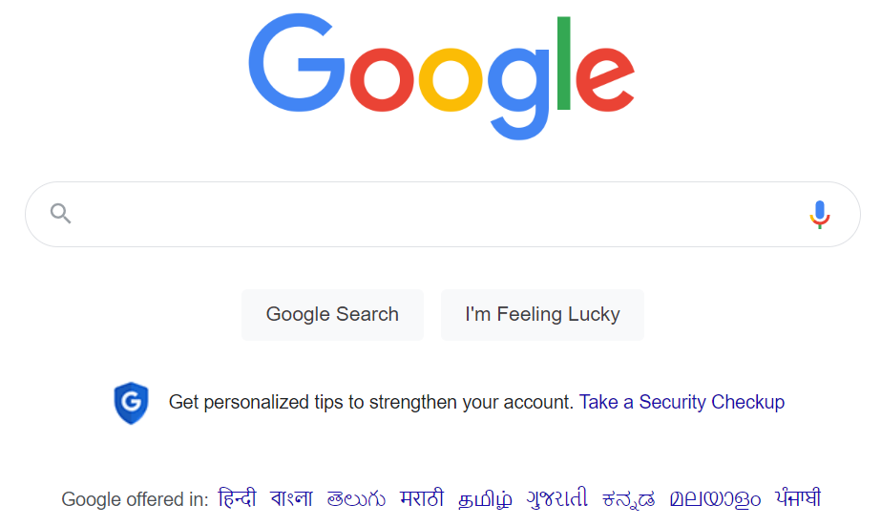

Step 2: Navigate to swag labs site using the URL- https://www.saucedemo.com/
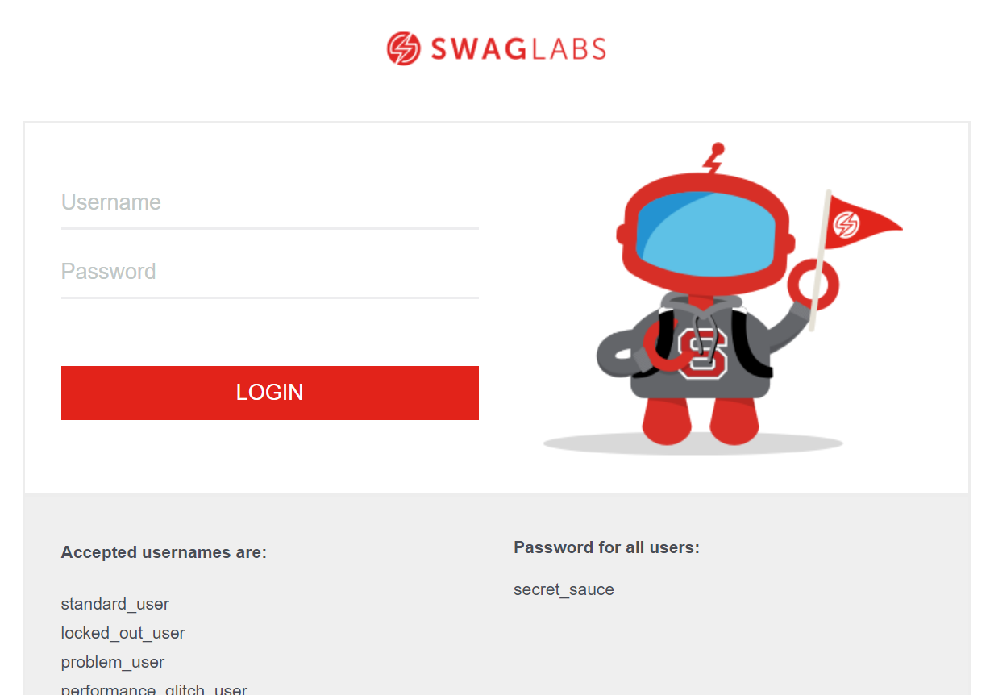

SWAG-8: Login for locked out user

Step 1: Navigate to swag labs site using the URL- https://www.saucedemo.com/

Step 2: Provide the username. Given: Username= locked_out_user
Step 3: Provide the password. Given: Password= secret_sauce

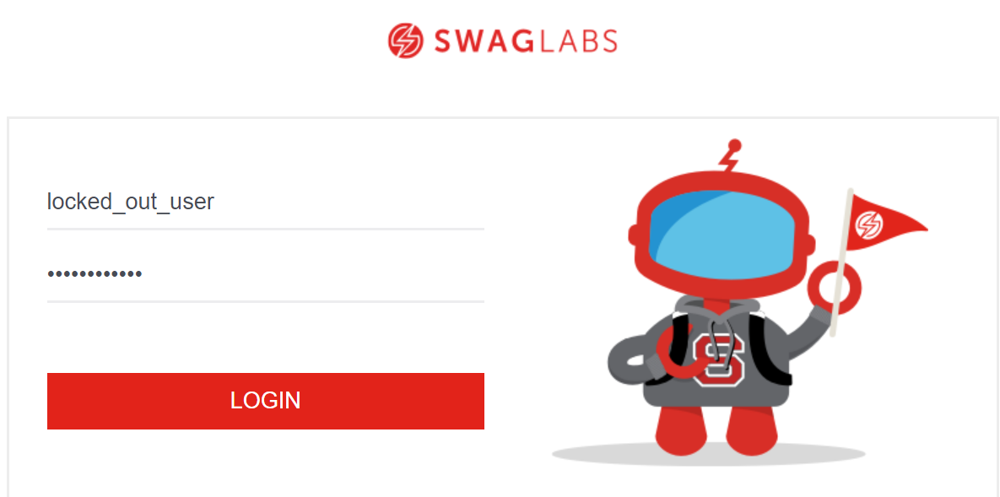
Step 4: Click on login button and user should not be able to login.
Step 5: It should display a message “Epic sadface: Sorry, this user has been locked out.”

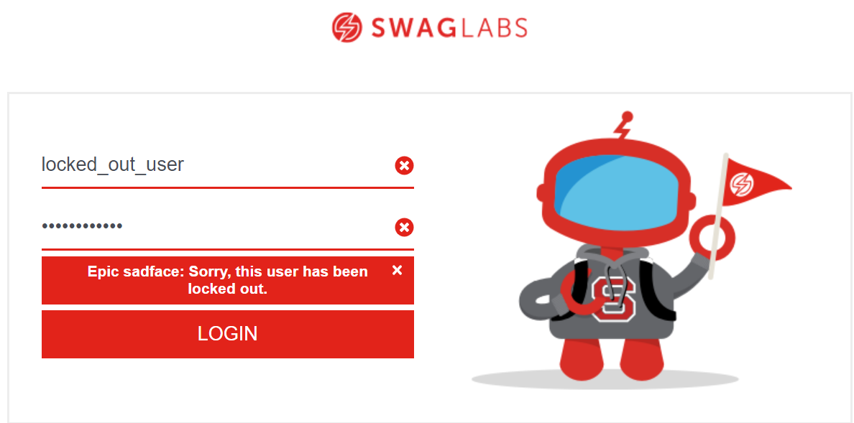

SWAG-9: Login for standard user

Step 1: Navigate to swag labs site using the URL- https://www.saucedemo.com/

Step 2: Provide username, Given: Username= standard_user
Step 3: Provide password, Given: Password= secret_sauce

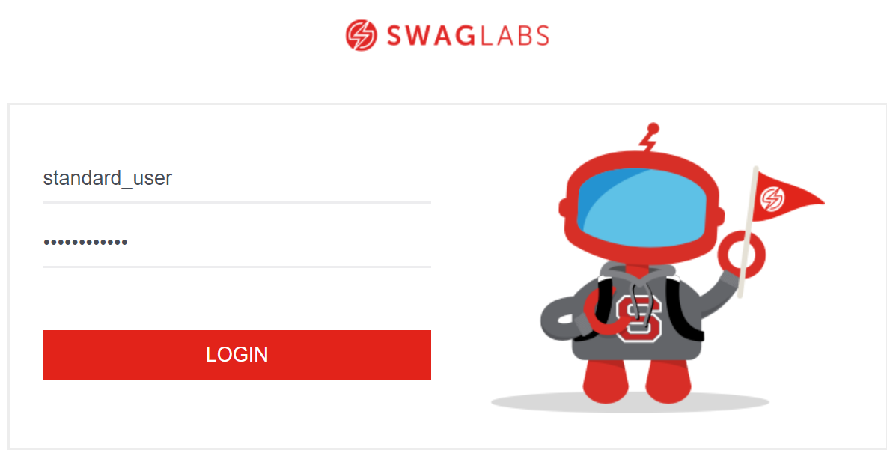
Step 4: Click on login button and user should be able to login.

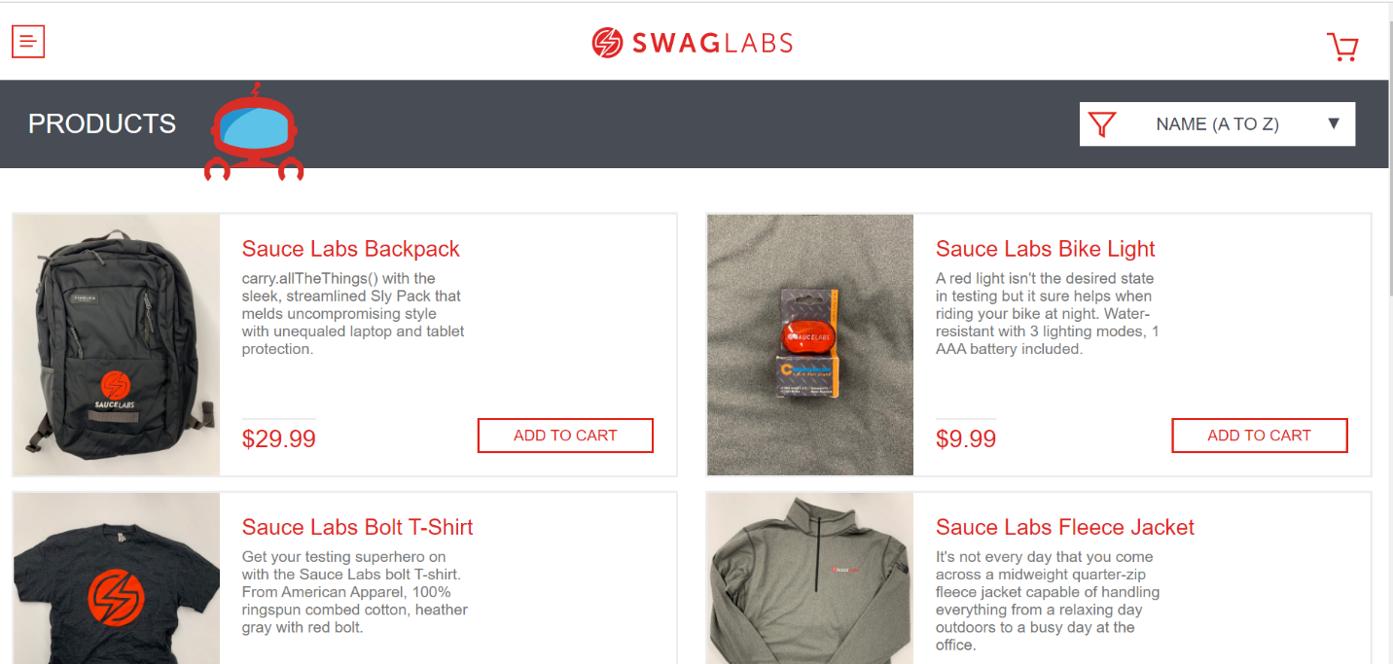

SWAG-10: Checking entities of menu icon

SWAG-11: Checking filter icon

Step 1: Navigate to swag labs site using the URL- https://www.saucedemo.com/

Step 2: Provide valid username and password and click login button. Given: Username= standard_user
Password= secret_sauce

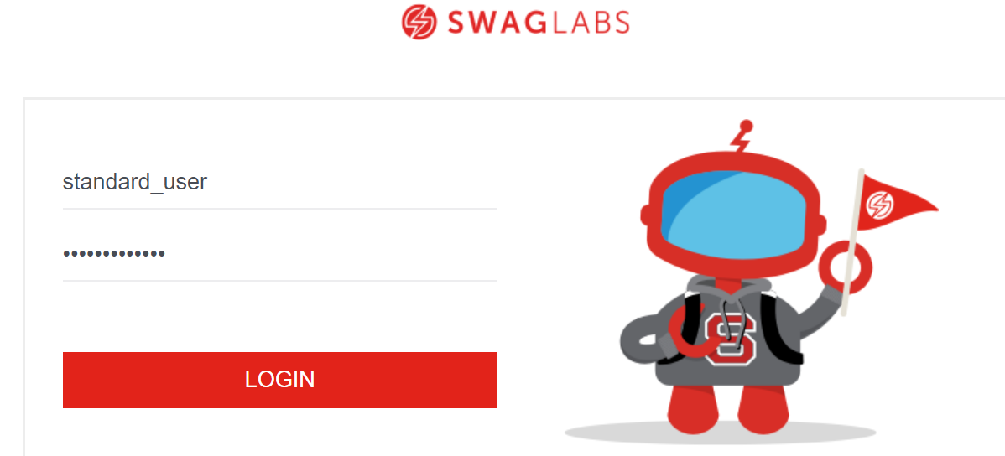

Step 3: Filter icon should be present on home page.



SWAG-12: Checking filters present in filter icon.

SWAG-13: Add to cart should be present in home page.

Step 1: Navigate to swag labs site using the URL - https://www.saucedemo.com/

Step 2: Provide valid username and password and click login button. Given: Username= standard_user
Password= secret_sauce

Step 3: ADD TO CART should be available to add items to cart in home page of Swag labs.

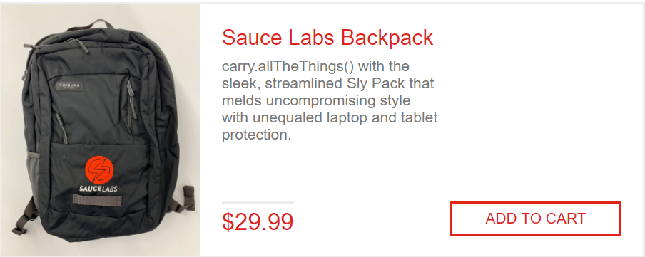

SWAG-14: Adding items to cart.

Step 1: Navigate to swag labs site using the URL - https://www.saucedemo.com/

Step 2: Provide valid username and password and click login button. Given: Username= standard_user
Password= secret_sauce

Step 3: By clicking ADD TO CART items should be added to cart.

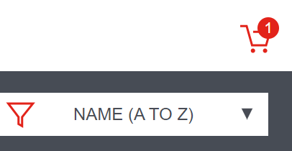

SWAG-15: Checking cart symbol.

Step 1: Navigate to swag labs site using the URL - https://www.saucedemo.com/

Step 2: Provide valid username and password and click login button. Given: Username= standard_user
Password= secret_sauce

Step 3: By clicking cart symbol, should be able to get list of items added.

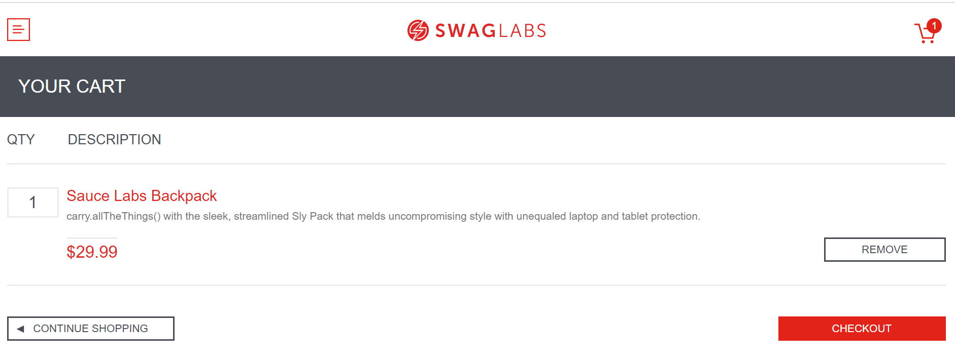

SWAG-16: Cart page header

SWAG-17: Checking entities of cart page.
SWAG-18: Checking REMOVE button

Step 1: Navigate to swag labs site using the URL - https://www.saucedemo.com/

Step 2: Provide valid username and password and click login button. Given: Username= standard_user
Password= secret_sauce

Step 3: Navigate to cart page by clicking cart symbol.

Step 4: By clicking REMOVE button it should remove items from cart.

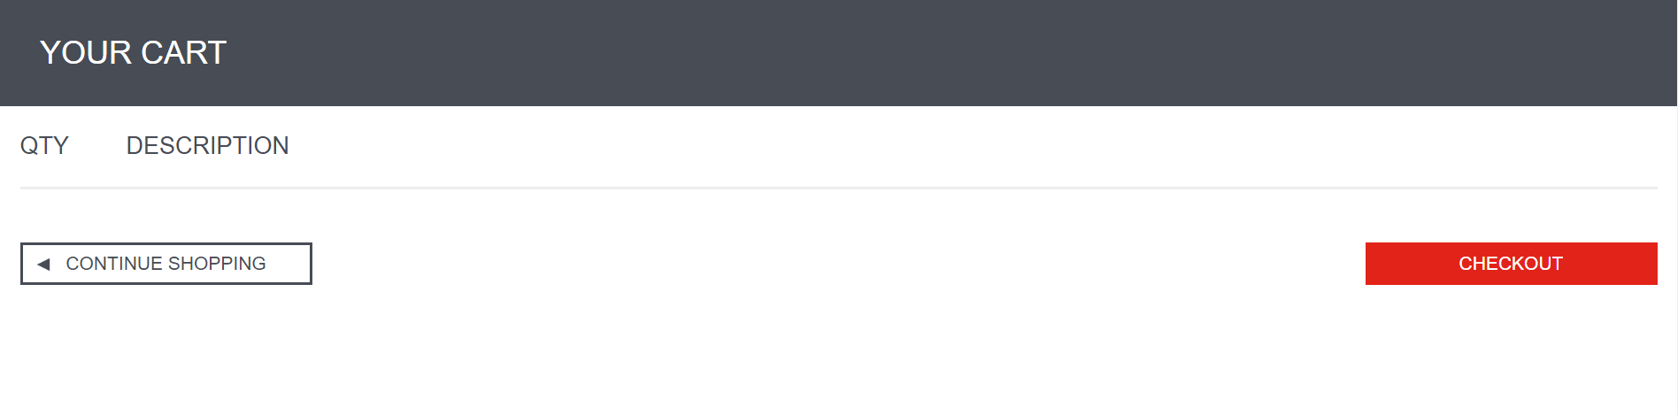

SWAG-19: Checking CHECKOUT button.

Step 1: Navigate to swag labs site using the URL - https://www.saucedemo.com/

Step 2: Provide valid username and password and click login button. Given: Username= standard_user
Password= secret_sauce

Step 3: Navigate to cart page by clicking cart symbol.

Step 4: By clicking CHECKOUT button it should navigate to next page that is checkout page.

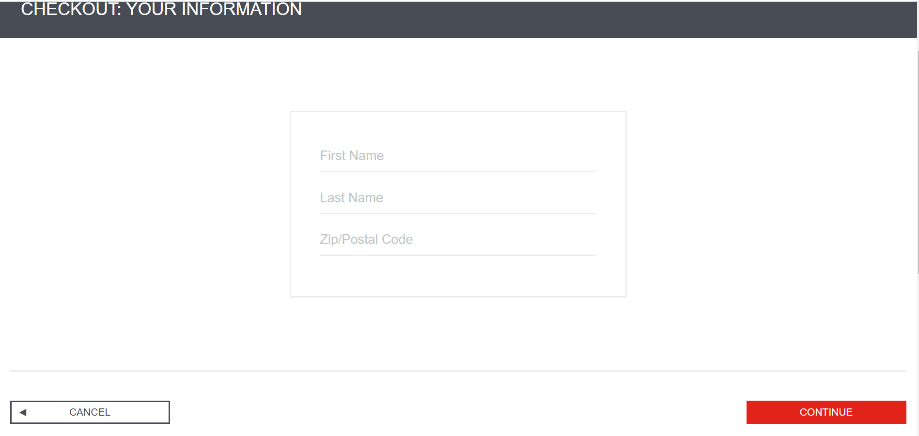

SWAG-20: Checking CONTINUE SHOPPING button.

Step 1: Navigate to swag labs site using the URL - https://www.saucedemo.com/

Step 2: Provide valid username and password and click login button. Given: Username= standard_user
Password= secret_sauce

Step 3: Navigate to cart page by clicking cart symbol.

Step 4: By clicking CONTINUE SHOPPING button user should navigate to previous home page.

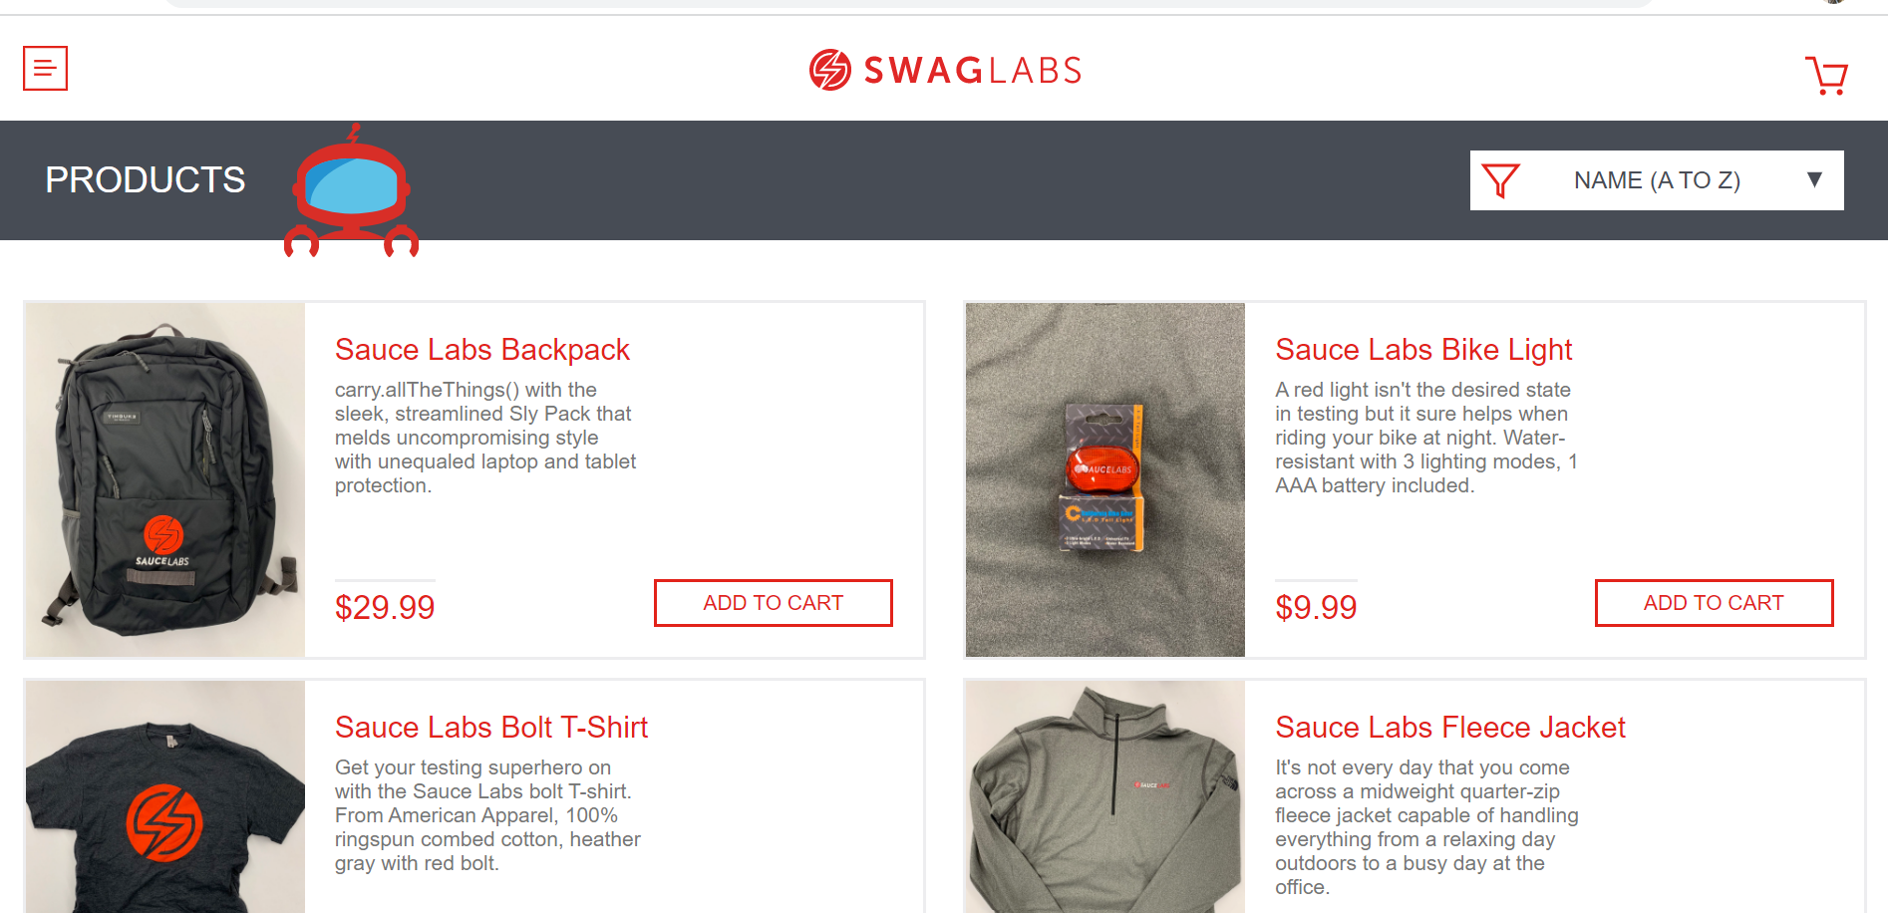

SWAG-21: Checkout page header
Step 1: Navigate to swag labs site using the URL - https://www.saucedemo.com/
Step 2: Provide valid username and password and click login button. Given: Username= standard_user
Password= secret_sauce

Step 3: Navigate to cart page by clicking cart symbol.

Step 4: By clicking CHECKOUT button it should navigate to next page that is checkout page.

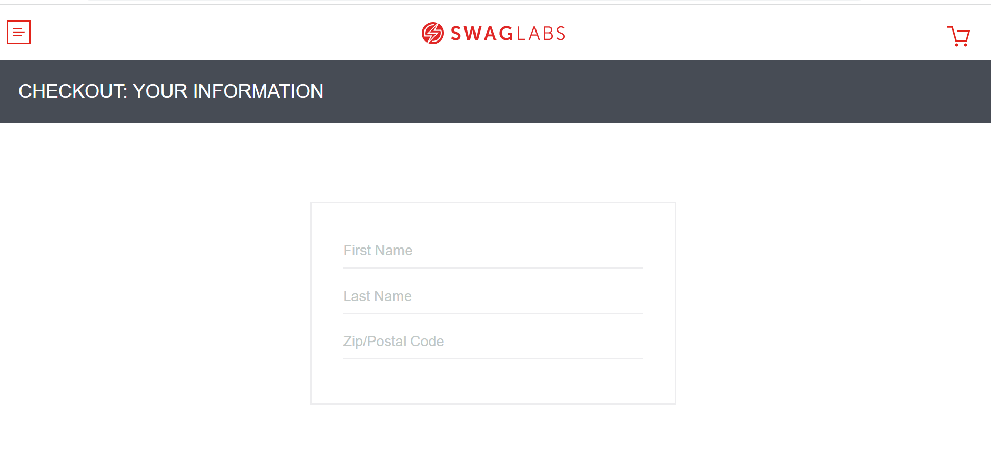
Step 5: Checkout page header should be “CHECKOUT: YOUR INFORMATION”

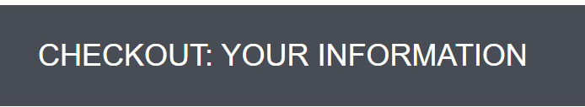
SWAG-22: Checkout page attributes

Step 1: Navigate to swag labs site using the URL - https://www.saucedemo.com/

Step 2: Provide valid username and password and click login button. Given: Username= standard_user
Password= secret_sauce

Step 3: Navigate to cart page by clicking cart symbol.

Step 4: By clicking CHECKOUT button it should navigate to next page that is checkout page.

Step 5: Checkout Page should have below attributes:
1. First Name (It should be Mandatory field)
2. Last Name
3. Zip/Postal Code (It should be 6 digits only)

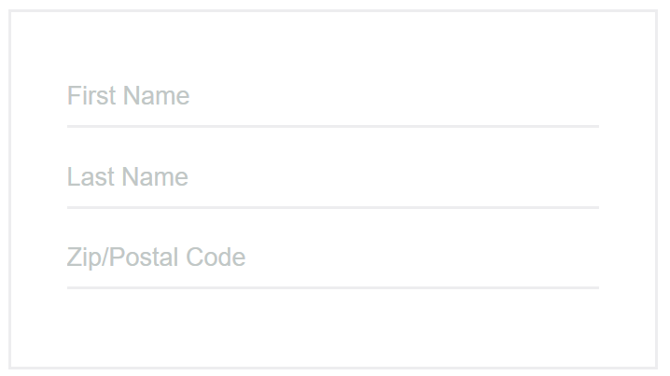

SWAG-23: Checking for length of ZIP/Postal code

SWAG-24: Only digits are accepted in ZIP/Postal code field.

SWAG-25: Checking First name field

Step 1: Navigate to swag labs site using the URL - https://www.saucedemo.com/

Step 2: Provide valid username and password and click login button. Given: Username= standard_user
Password= secret_sauce

Step 3: Navigate to cart page by clicking cart symbol.

Step 4: By clicking CHECKOUT button it should navigate to next page that is checkout page.

Step 5: Provide last name, ZIP/postal field and leave First name field empty then user should not be able to navigate to next page.
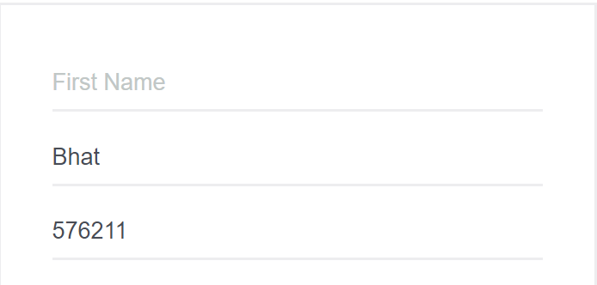

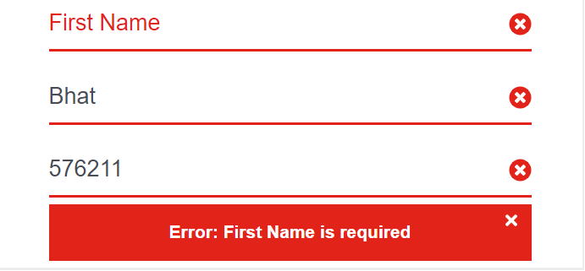
SWAG-26: Checking Last name fields.

